MongoDb Assignment

1.Install MongoDb Databse server

2. create Directory to store MongoDb Data files.

3. Set necessary path environment variable

4. startup mongoDb database
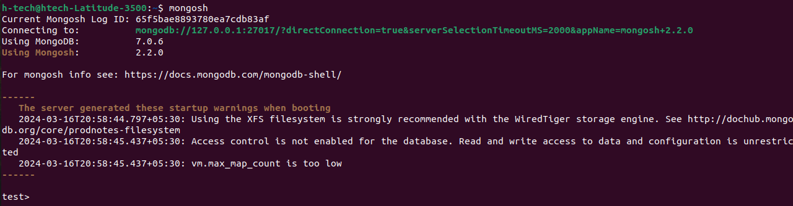

6. view List of available databases.

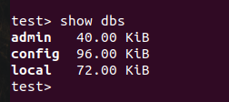

7. Create a new database named Cdac and connect to it.

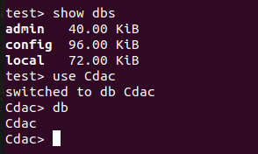

8 & 9. View list of available collections in database and create a new collection name Library.

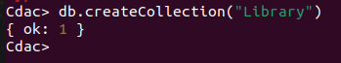

10. Insert The following document in the library collection
title:’MongoDb Programming’,
author : ‘Sameer’,likes:100

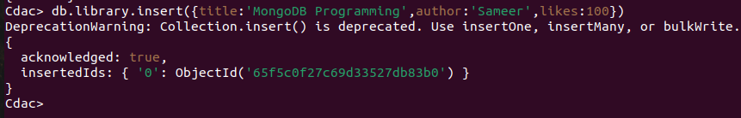

11. View The recently inserted document and note the _id field.

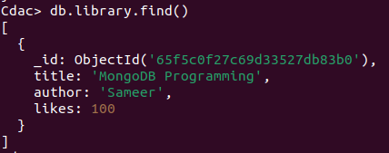

12. Insert the Another document in the Library Collection as Follows
title:’MySQL Programming’,aiuthors:[‘Jack’,’Jill’],likes:200

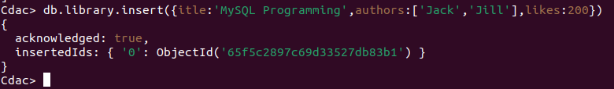
13. view The inserted Documents.
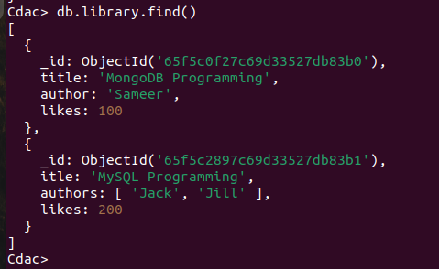

14. View only the first inserted document.

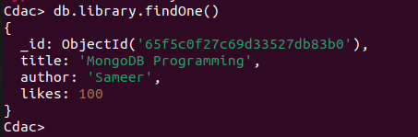

15. View The Document using the Pretty Method .
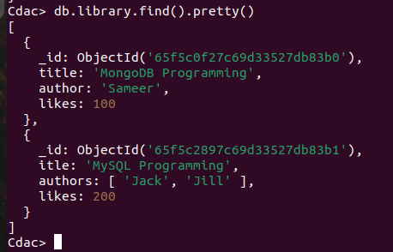

16 . Update The Document where author name Sameer and change it to sameer Dehadrai

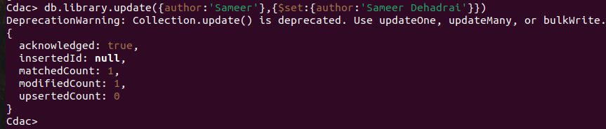
17.Delete all Document That Have 100 Likes.

18. Drop The Library Collection.
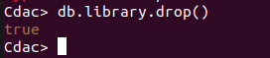

19. Drop The CDAC Database
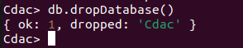

20 . Exit From MongoDB shell


21. Stop MongoDb Server

